

HANDS-ON LABALATORY TRAINING IN ELECTRONICS AND EMBEDDED SYSTEMS

A REPORT SUBMITTED TO THE

FACULTY OF ENGINEERING DESIGN AND TECHNOLOGY

UGANDA CHRISTIAN UNIVERSITY

IN PARTIAL FULFILLMENT OF THE REQUIREMENTS FOR THE DEGREE OF

BACHELOR OF SCIENCE IN INFORMATION TECHNOLOGY

IN

DEPARTMENT OF COMPUTING AND TECHNOLOGY

THREE WEEKS’ PERIOD OF TRAINING

ACADEMIC YEAR 2024/2025

BY

OTWIINE ELIZABETH

REG NO: S23B13/087

Tel: 0758984979

Email: otwiineelizabeth@gmail.com

# DECLARATION

I OTWIINE ELIZABETH certify that in the preparation of this report, I have observed the provisions of Uganda Christian University Code of Ethics. Further, I certify that this work is free of plagiarism and all materials appearing in this report have been properly quoted and attributed.

I agree to indemnify and save harmless UCU from all claims that may be asserted or that may arise from any copyright violation.

I hereby certify that the work in this report is my original work, and it does not include any copied parts without the appropriate citation.

**Student Name & Signature:**

**………………………………………**

**Date: ………………………………...**

# SUMMARY

The three-week training program was designed to provide a well-rounded understanding of fundamental concepts in electronics and embedded systems. The program covered various aspects, starting with the basic principles of analog and digital electronics, exploring the intricacies of electrical wiring, and concluding with an introduction to the world of embedded systems.

The training program utilized a hands-on approach, encouraging active participation and practical learning. We were engaged in various projects and exercises, reinforcing theoretical concepts and fostering practical problem-solving skills. The curriculum was tailored to cater to diverse learning styles and ensure that each we gained a comprehensive understanding of the subjects.

# ACKNOWLEDGEMENT

I would like to extend my sincere gratitude to the Uganda Industrial Research Institute for organizing and facilitating an exceptional three-week training program on Electrical Wiring, Digital and Analog Electronics, and Embedded Systems.

My heartfelt thanks go to the instructors and staff who shared their expertise and provided valuable insights throughout the training. Their dedication and professionalism have greatly enhanced my understanding of these critical areas and have equipped me with the skills necessary to advance in the field.

I also appreciate the opportunity to engage with fellow students, whose diverse participation and collaboration contributed to a rich and collaborative learning environment.

Special thanks to Uganda Christian University for its invaluable assistance and support during this training program. Your contributions have been instrumental in making this learning experience a success.

This training program has been a significant milestone in my academic life, and I am grateful for the support and resources provided by both the Uganda Industrial Research Institute and Uganda Christian University.

Thank you.

# LIST OF FIGURES

Figure 1 showing house plan 4

Figure 2 showing electrical wiring 5

Figure 3 showing students wiring 6

Figure 4 showing electrical lab trainer 7

Figure 5 showing electrical lab trainer 9

Figure 6 showing the project 10

Figure 7 showing no intruder alert 12

Figure 8 showing the finished project 13

Figure 9 showing intruder alert device 14

# TABLE OF CONTENTS

DECLARATION AND CERTIFICATE OF ORIGINALITY …………………………. ii

SUMMARY ……………………………………………………………….……………. iii

ACKNOWLEDGEMENT …………………………………………………………….…iv

**LIST OF FIGURES** ……………………………………………….…….………….…. v

TABLE OF CONTENTS …………………………………………………….………….vi

**ABBREVIATIONS**……………………………………………….…….……………...viii

1. [INTRODUCTION TO UIRI] …………………………………………………...1  
   1.1 [History and Background] ……………………………………………...……1  
   1.2 [Facilities and Equipment] …………………………………………….…….1  
   1.3 [Partnerships and Collaborations]………………………………………..…..2  
   1.4 [Services Offered] ……………………………………….…………………...2  
   1.5 [Impact and Achievements] …………………………….……………………3
2. [ELECTRICAL WIRING AND INSTALLATION] …………….………………4  
   2.1 [Common Wiring Materials and Techniques] ………………….……………4  
   2.1.1 [Overview of Electrical Wiring Principles] ……………………..…………5  
   2.1.2 [Hands-on Practical Sessions] ………………………………………..……5  
   2.1.3 [Electrical Safety Considerations] ………………………………………....6
3. [ANALOG AND DIGITAL ELECTRONICS] ………………………………….7  
   3.1 [Fundamentals of Digital and Analog Signals**]**……………………………….7  
   3.1.1 [Applications of Analog and Digital Electronics] ………………………....8  
   3.1.2 [Conversion between Digital and Analog Formats] ……………………….8  
   3.1.3 [Signal Processing and Transmission] ………………………………....…..8
4. [EMBEDDED SYSTEMS] ………………………………………………………10  
   4.1 [Overview of the Smart House Security System Project] ……………………10  
   4.1.1 [Hardware Components and Architecture] ……………………………...…11  
   4.1.2 [Sensor Integration and Data Processing] ………………………………….12  
   4.1.3 [Security Features and Functionalities] …………………………………….12  
   4.1.4 [Challenges and Lessons Learned in our Project] ……………………...….13  
   4.1.5 [Future Enhancements] ………………………………………..…………...14
5. [CONCLUSIONS AND RECOMMENDATIONS] …………………….………15  
   5.1 [**challenges faced during the three week training**]...…………………..…..15  
   5.2[how the challenges were overcome] ……………………………..…………..16

5.3 [**recommendations]** …………………………………...…….………………17

**[**REFERENCES**]** ……………………………………………….……………...…………18

# ABBREVIATIONS

[Abbreviation] [Abbreviation description]

UCU Uganda Christian University

UIRI Uganda Industrial Research Institute.

NGOs Non-Governmental Organizations

IRDC Industrial Research and Development Center

# CHAPTER 1

# INTRODUCTION TO UIRI:

#### History and Background

The Uganda Industrial Research Institute (UIRI) was established in 1965 as the Industrial Research and Development Center (IRDC). It was originally established to support the growth of the newly independent Uganda's nascent industrial sector. In the 1970s, IRDC faced challenges due to political instability and economic hardship. However, it managed to continue its research activities, focusing on areas like food processing, leather technology, and building materials.

In 1986, after the National Resistance Movement came to power, IRDC was reorganized and renamed the Uganda Industrial Research Institute. This reorganization marked a new era for UIRI, with a renewed focus on innovation and collaboration with the private sector. Over the years, UIRI has continued to adapt to the changing needs of the Ugandan industrial landscape, expanding its research areas and building partnerships with key stakeholders.

#### Facilities and Equipment

UIRI boasts a range of well-equipped laboratories and facilities designed to support its research activities. These facilities are strategically located across the country, providing access to diverse resources and a wide range of expertise.

Some of UIRI's key facilities include:

* Food Science and Technology Laboratories
* Biotechnology Laboratories
* Materials Science and Engineering Laboratories
* Environmental Science Laboratories
* Pilot Plants for Testing and Validation
* Workshops and Fabrication Facilities

UIRI's facilities are equipped with modern scientific equipment and instrumentation, enabling its researchers to conduct cutting-edge research and develop innovative solutions. The organization invests in continuously upgrading its equipment to remain at the forefront of technological advancements.

#### Partnerships and Collaborations

UIRI recognizes the importance of collaboration in achieving its goals. The organization actively engages in partnerships with various stakeholders, including:

* Government Ministries and Agencies
* Private Sector Companies
* Research Institutions and Universities
* International Development Organizations
* Non-Governmental Organizations (NGOs)

These partnerships allow UIRI to leverage resources, expertise, and networks to address complex challenges and develop sustainable solutions. The organization is committed to fostering strong relationships with its partners, ensuring that its research activities are aligned with the needs of the Ugandan industrial sector.

#### Services Offered

UIRI offers a wide range of services to support the development and growth of Uganda's industrial sector. These services are tailored to meet the specific needs of businesses and organizations across different sectors.

* Research and Development Services
* Technology Transfer and Commercialization
* Testing and Analysis Services
* Technical Consultancy Services
* Training and Capacity Building Services
* Incubation and Business Development Support

UIRI's services are designed to help businesses innovate, improve their products and processes, and access new markets. The organization strives to provide high-quality and affordable services, ensuring that they are accessible to businesses of all sizes.

#### Impact and Achievements

UIRI has made significant contributions to the development of Uganda's industrial sector, driving innovation and creating a more competitive and sustainable industrial landscape.

Some of UIRI's key achievements include:

* Developing new and improved products and processes for various industries
* Transferring technologies to businesses, leading to increased efficiency and productivity
* Providing training and capacity building opportunities for industry professionals
* Supporting the creation of new businesses and jobs in the industrial sector
* Contributing to the development of national standards and regulations for various industries

UIRI's impact extends beyond its immediate research activities, as it has played a key role in fostering a culture of innovation and collaboration within the Ugandan industrial sector. The organization's continued dedication to research, innovation, and partnership will continue to drive positive change and contribute to a more prosperous Uganda.

# CHAPTER 2

# ELECTRICAL WIRING AND INSTALLATION:

The first week of the training focused on the fundamentals of electrical wiring. This involved a comprehensive exploration of the principles, materials, and techniques essential for understanding and implementing electrical systems. The week's content aimed to equip learners with the knowledge and skills necessary to work safely and effectively with electrical wiring.

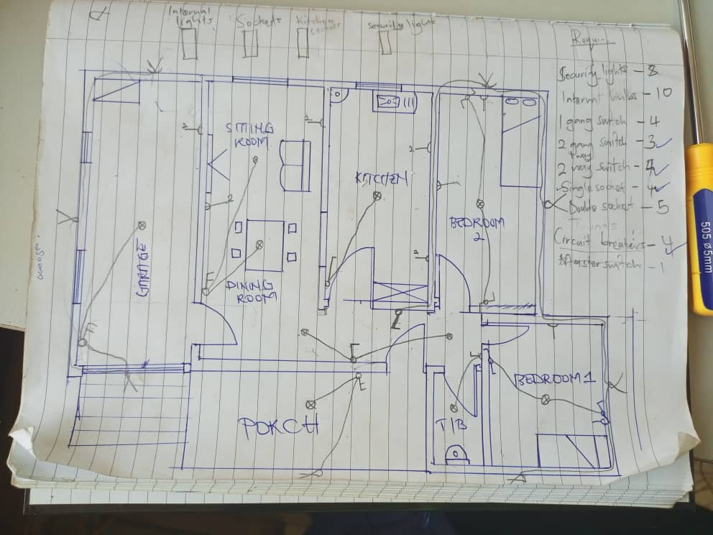

Figure 1 showing house plan

Common Wiring Materials and Techniques

A wide range of materials are used in electrical wiring, each suited for specific applications. Common wiring materials include copper and aluminum conductors, various types of insulation, and connectors. Different wiring techniques, such as wire splicing, termination, and cable routing, were examined, highlighting the importance of adhering to safety standards and best practices. The selection of appropriate materials and techniques is crucial to ensure a safe and reliable electrical system.

#### Overview of Electrical Wiring Principles

The study of electrical wiring principles began with an understanding of basic concepts such as voltage, current, and resistance. The relationship between these fundamental quantities, known as Ohm's law, was thoroughly discussed. Additionally, the importance of grounding and grounding techniques was emphasized. Grounding serves as a safety measure, providing a path for electrical current to flow safely to the earth in case of a fault.

#### Hands-on Practical Sessions

The training included several hands-on practical sessions where we could apply the knowledge and skills learned in a simulated environment. These sessions provided a valuable opportunity for us to practice wiring techniques, troubleshoot problems, and gain confidence in their abilities. Under the guidance of experienced instructors, we worked on various electrical projects, such as electrical installation in a home setting, switches, ensuring compliance with safety protocols and best practices.

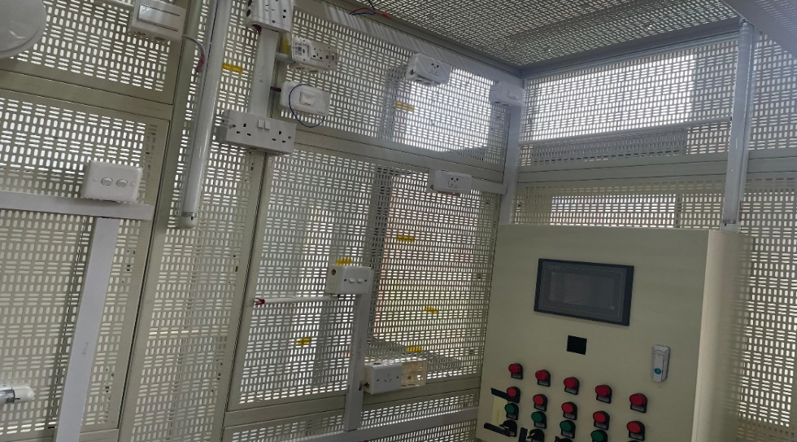

Figure 2 showing electrical wiring

#### Electrical Safety Considerations

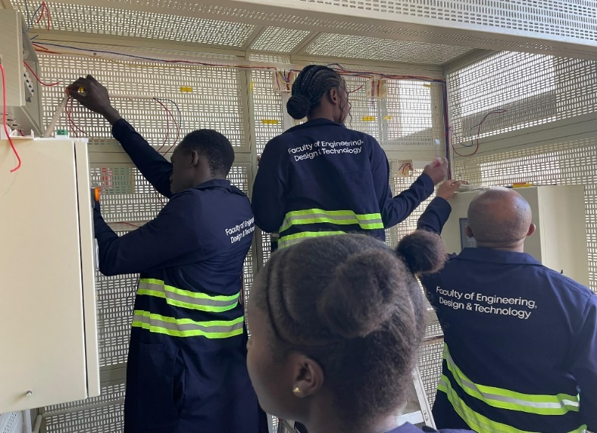Electrical safety is paramount in any electrical wiring project. The importance of following safety regulations was stressed throughout the week. We were introduced to safety precautions, such as working with de-energized circuits, wearing personal protective equipment (PPE), and using appropriate tools. Additionally, the proper use of safety devices, like fuses and circuit breakers, was covered, emphasizing their role in preventing electrical hazards.

Figure 3 showing students wiring

-+

**CHAPTER 3**

# ANALOG AND DIGITAL ELECTRONICS

The second week delved into the realm of digital and analog electronics and signals, covering their fundamental principles and applications. This week's focus was on understanding the characteristics, conversions, and processing methods associated with these two important signal types.

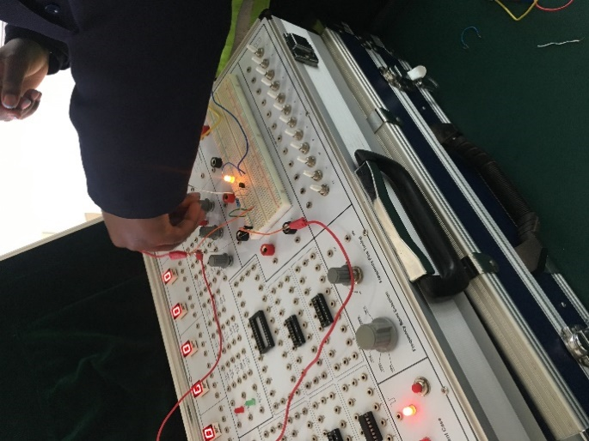

Figure 4 showing electrical lab trainer

#### Fundamentals of Digital and Analog Signals

The distinction between digital and analog signals was thoroughly explained, highlighting the key differences in their representation and transmission. Digital signals are discrete and use a finite number of values, typically represented by binary digits (0s and 1s), while analog signals are continuous and can take on an infinite number of values within a defined range. The advantages and disadvantages of each type of signal were discussed, including their suitability for various applications

#### Applications of Analog and Digital Electronics

The pervasiveness of analog and digital electronics is evident in almost every aspect of modern life. From the everyday devices we use to the complex systems that power our world, these two fundamental areas of electronics are inextricably intertwined.

Here are some key application areas:

* Consumer Electronics: Smartphones, TVs, computers, audio systems, and gaming consoles all rely on intricate combinations of analog and digital circuits.
* Industrial Automation: Robotics, process control systems, and industrial machinery extensively use analog and digital electronics for sensing, control, and automation.
* Communication Systems: From cellular networks to satellite communication, analog and digital electronics are crucial for transmitting and receiving information.
* Medical Devices: Medical imaging equipment, pacemakers, hearing aids, and other life-saving devices depend on advanced analog and digital circuitry for accurate diagnosis and treatment.

#### Conversion between Digital and Analog Formats

The conversion between digital and analog formats is a crucial aspect of signal processing. Analog-to-digital conversion (ADC) and digital-to-analog conversion (DAC) processes were explained in detail. ADC involves converting a continuous analog signal into a discrete digital signal, while DAC reverses this process. Understanding these conversion techniques is essential in various applications, such as audio and video processing, data acquisition, and control systems.

#### Signal Processing and Transmission

Signal processing involves manipulating signals to extract information, enhance quality, or prepare them for transmission. Common signal processing techniques, such as filtering, amplification, and modulation, were explored. The transmission of signals, including the use of various media like wires, optical fibers, and wireless channels, was discussed, emphasizing the challenges associated with signal distortion and noise.

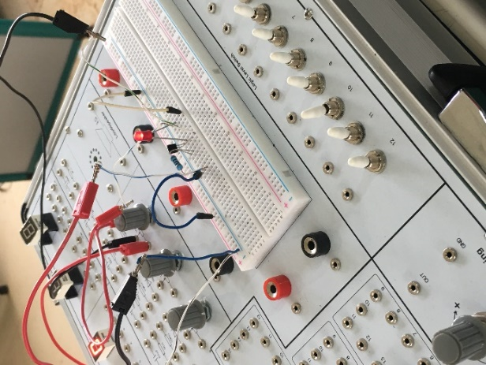

Figure 5 showing electrical lab trainer

#### Key Takeaways

Key takeaways include:

* Analog electronics deals with continuous signals and relies on components like resistors, capacitors, and transistors.
* Digital electronics uses discrete signals represented by binary values (0s and 1s) and utilizes logic gates and flip-flops.
* Analog-to-digital converters (ADCs) and digital-to-analog converters (DACs) bridge the gap between analog and digital signals.
* Combinational logic circuits produce outputs based on current inputs, while sequential logic circuits incorporate memory to maintain previous states.
* Analog and digital electronics are essential for countless applications, shaping our modern world.

# CHAPTER 4

# EMBEDDED SYSTEMS:

The final week of the training introduced the fascinating world of embedded systems. Embedded systems are computer systems that are designed to perform specific tasks within larger systems. This week explored the architecture, programming, and applications of these ubiquitous systems, providing insights into their vital role in modern technology.

Under this, we did a project where we were required to come up with a smart house security system that if there’s an intruder it detects, beeps and sends SMSs and even calls the owner automatically. The system could also turn lights on automatically when motion is detected

# 

Figure 6 showing the project

#### Overview of the Smart House Security System Project

Our project focused on developing a smart home security system that utilized embedded systems to provide real-time monitoring and control of various security aspects. The system aimed to enhance safety and security for homeowners while offering convenience and remote management.

#### Security Monitoring

The system incorporated multiple sensors, including motion detectors, door and window contacts, and smoke detectors. These sensors were strategically placed throughout the house to detect suspicious activity or potential hazards.

#### Remote Access and Control

The system allowed homeowner to remotely monitor the status of their security system, receive alerts, and control devices such as lights and locks via a mobile app or web interface.

#### Automated Response

The system could be programmed to trigger specific actions based on pre-defined scenarios. For example, if a motion sensor detected movement, the system could activate an alarm, send a notification to the homeowner, or automatically turn on lights.

#### Hardware Components and Architecture

The hardware architecture of the smart house security system involved a central control unit, various sensors, and actuators. The central control unit, typically a microcontroller, acted as the brain of the system, processing data from sensors and controlling the actuators.

#### Microcontroller

The microcontroller is the core of the embedded system. It handles the processing of sensor data, decision-making, and control of actuators.

#### Sensors

Sensors detect various physical parameters, such as motion, temperature, and light. They provide real-time information about the environment.

#### Actuators

Actuators are devices that respond to signals from the microcontroller. They can be used to control lights, locks, alarms, or other security-related devices.

#### **Sensor Integration and Data Processing**

Integrating different sensors into the smart house security system required careful consideration of their types, functionalities, and communication protocols. The system used a variety of sensors, each providing specific data.

#### Motion Sensors

Motion sensors detected movement within the house, triggering alerts or activating security measures.

#### Door and Window Contacts

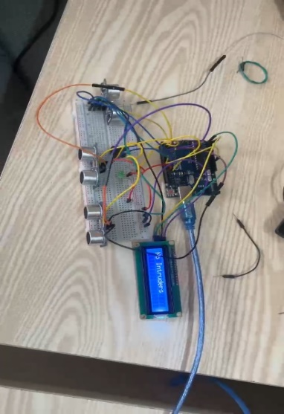These sensors monitored the status of doors and windows, detecting unauthorized entry.

Figure 7 showing no intruder alert

#### Security Features and Functionalities

The smart house security system incorporated a range of security features and functionalities to enhance the protection of the home and its occupants.

|  |  |
| --- | --- |
| Feature | Description |
| Alarm System | Activated by sensors detecting suspicious activity, triggering a loud siren and notifying the homeowner. |
|  |  |
| Access Control | Allowed the homeowner to control door locks remotely, granting or denying access to authorized individuals. |
| Emergency Response | Provided a mechanism for contacting emergency services in case of a security breach or other emergency. |

# 

Figure 8 showing the finished project

#### Challenges and Lessons Learned in our project

Developing a functional and reliable smart house security system presented various challenges, from hardware selection to software development and deployment.

#### Sensor Calibration

Ensuring accurate sensor readings required careful calibration and adjustments to minimize false alarms.

#### Network Security

Securing communication channels and protecting the system from unauthorized access was paramount.

#### Power Management

Optimizing power consumption and ensuring reliable operation even during power outages was crucial.

#### User Experience

Designing an intuitive and user-friendly interface for controlling and monitoring the system was essential.

#### **Future Enhancements**

The smart house security system project demonstrated the potential of embedded systems to enhance security, safety, and convenience in residential environments.

#### Enhanced Security

Further development could incorporate artificial intelligence to improve anomaly detection and threat assessment.

#### Energy Efficiency

The system could be optimized to automate energy-saving measures, such as turning off lights and appliances when not in use.

#### Interoperability

Integrating the system with other smart home devices could create a more holistic and interconnected home automation experience.

#### Automated Tasks

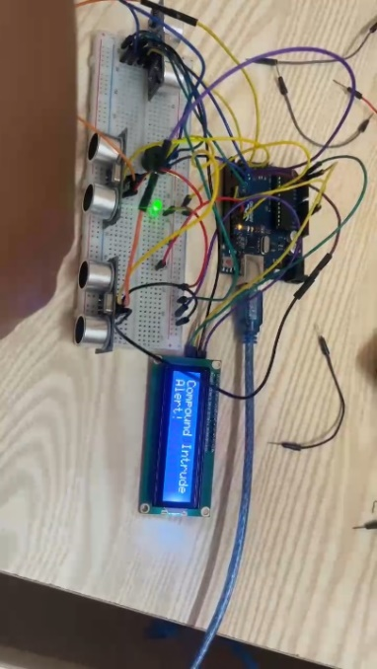The system could be extended to automate more tasks, such as controlling appliances, adjusting thermostats, and scheduling event

Figure 9 showing intruder alert device

# CHAPTER 5

# CONCLUSIONS AND RECOMMENDATIONS:

#### We faced the following challenges in our three-week training program.

1. Technical Difficulties:

The training sessions were frequently disrupted by unreliable internet connectivity, which severely hampered the delivery of digital content and interrupted online demonstrations. This inconsistency made it challenging to maintain a continuous learning experience which delayed progress. The lack of stable connectivity also impeded access to online resources and real-time collaboration tools essential for modern educational practices.

1. Time Constraints:

The training, compressed into a three-week period, afforded little time for in-depth exploration of complex topics. The condensed schedule exerted significant pressure on both instructors and us. The rapid pace limited opportunities for hands-on practice, reflection, and reinforcement of learned concepts, which are crucial for mastering technical subjects.

3.Limited Knowledge of Training Content:

Some of us entered the training with varying levels of prior knowledge, some with minimal background in the subjects covered. This disparity in foundational knowledge made it challenging to engage in advanced topics and execute complex practical tasks. Many of us struggled to grasp the material. This uneven knowledge base created challenges in maintaining a cohesive learning environment, as instructors had to balance between catering to novices and advancing learners

#### How the above challenges were overcome

1. Technical Difficulties:

For internet connectivity issues, necessary resources and instructional materials were pre-downloaded, enabling offline access and ensuring continuity in learning. Additionally, a local server was set up to host digital content, reducing dependence on external internet connectivity and enhancing access to training materials.

1. **Time Constraints:**

Essential topics were prioritized, focusing on core competencies most beneficial to all of us. Extended sessions and supplementary materials were provided for self-study, allowing us to deepen their understanding outside scheduled training hours. Instructors made use of flipped classroom techniques, practical application was emphasized during in-class time, maximizing hands-on learning opportunities.

1. Inadequate Prior Knowledge:

To bridge knowledge gaps, we facilitated peer-to-peer learning opportunities. Participants with stronger backgrounds were paired with those needing extra assistance, creating a supportive learning network that fostered knowledge exchange and collaborative problem-solving.

#### Recommendations:

1. Enhance Technical Infrastructure:

Invest in robust internet infrastructure to ensure reliable connectivity, crucial for the seamless delivery of digital content and online demonstrations. Consider integrating a hybrid training model that leverages both online and offline resources. Establish dedicated internet lines or satellite connections to mitigate connectivity issues. Additionally, equip the training facility with modern IT infrastructure, including high-speed networks and cloud-based learning platforms, to facilitate smooth and efficient digital learning experiences.

1. Extended Training Duration:

Extend the training duration to allow for a more thorough exploration of complex topics. Incorporate flexible scheduling options, such as weekend workshops or evening sessions, to provide additional learning opportunities without overwhelming participants. Offer periodic refresher courses and advanced training modules to reinforce learning and facilitate continuous skill development. Encourage lifelong learning by providing access to ongoing educational resources and professional development opportunities.

3. Enhanced Pre-Training Preparation:

Develop pre-training preparation materials and modules to equip participants with basic knowledge before the program starts. This preparatory work will help level the playing field and ensure that all participants have a foundational understanding of key concepts.

Create tailored learning paths based on initial assessments, providing additional resources and targeted instruction to address specific knowledge gaps. This customization will help participants engage with the content more effectively and at their own pace.

* Expanding the training program to include more advanced topics in embedded systems, such as real-time operating systems and wireless communication.
* Introducing participants to industry-standard tools and software used in electronics design and development.
* Organizing regular networking events for participants to connect with industry professionals and explore job opportunities.

# 

# REFERENCES

* <https://www.uiri.go.ug/about>
* <https://github.com/OTWIINE-ELIZABETH>